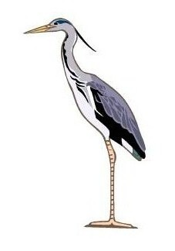
THE HERON PRACTICE
Dr Ajay Ojha
John Scott Health Centre Dr Mareeni Raymond
Green Lanes Dr Syed Akhtar
London N4 2NU Dr Anchal Chopra-Chhabra

Change of Details Form

Please complete the following depending on the changes being made:

Name of Patient: __________________________________________________________

Date of Birth: __________________________________________________________

NHS Number (if known): ________________________________________________________

New mobile Number: ___________________________________________________________

New home (landline Number: _______________________________________________

New Address: ___________________________________________________________

_________________________________________________________

_________________________________________________________

Change of Title: __________________________________________________________

Chage of First Name: __________________________________________________________

Change of Surname: ___________________________________________________________

